Introduction:
- What happened over the summer that made General Robert E. Lee decide to invade Union soil in early September?
- Why was McClellan confident and ready to rush to fight the Confederate army?

Opening Action & Dunker Church:
- Where does Lee choose to set up a defensive position? Why?
- What three places did most of the opening action center around?
- Throughout the battle, the cornfield changed hands six times. In the end, why did the Union fail to follow up on its advantage?

Sunken Road:
- What advantage in experience did the Confederates have over the Union soldiers?
- What mistakes are made by the commanding officers? How does this affect the battle?
- What nickname is given to the Sunken Lane? Why?

Burnside’s Bridge:
- Where is Lee most vulnerable? Who is ordered to target that area?
- Why is it so difficult for Burnside’s men to cross the bridge at Antietam Creek? How many assaults does it take for Burnside to take the bridge?
- What happens to the Confederates?

Final Attack:
- Why does Lee have time to reorganize before the final attack?
- Who arrives to reinforce Lee’s army? What does this do?
- Why does Lee have the opportunity to slip back into Virginia the next day?

Conclusion:
- Who won the battle?
- What happens to McClellan after Antietam? Why?
- What role does photography play in this battle?
- What does Lincoln do with the victory at Antietam?
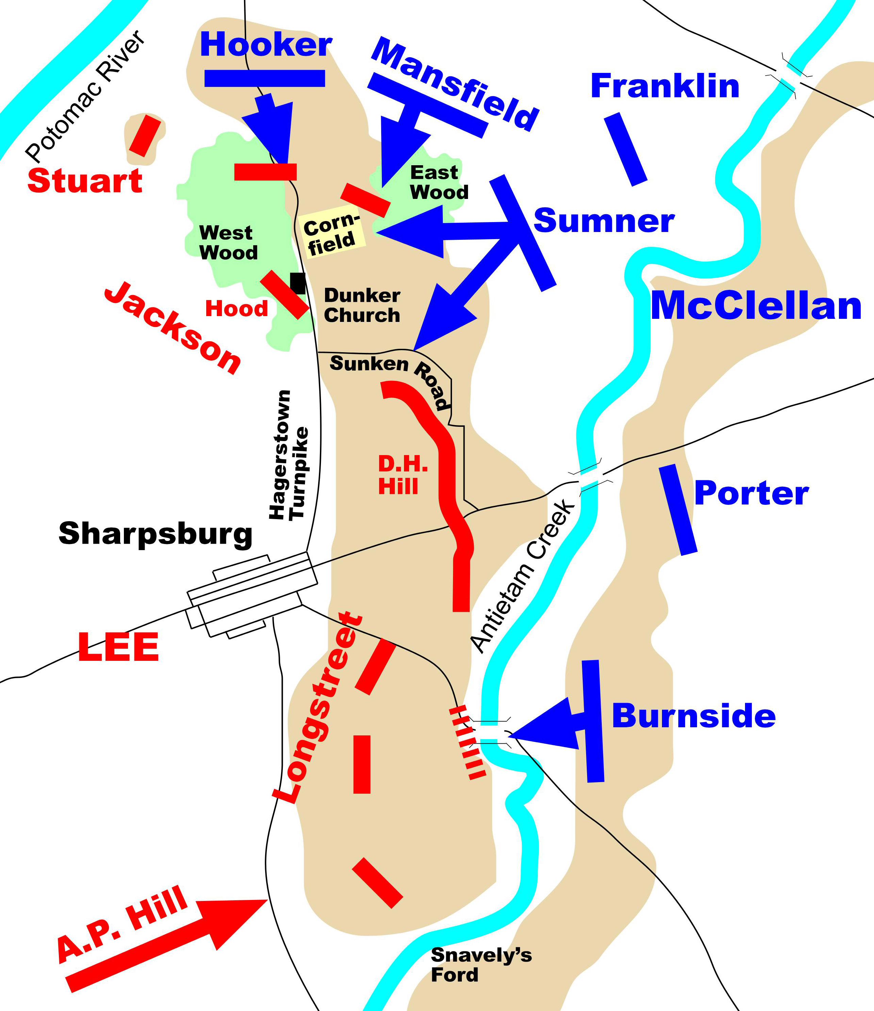
Introduction:
Union
- What happened over the summer that made General Robert E. Lee decide to invade Union soil in early September?
- Why was McClellan confident and ready to rush to fight the Confederate army?

Opening Action & Dunker Church:
- Where does Lee choose to set up a defensive position? Why?
- What three places did most of the opening action center around?
- Throughout the battle, the cornfield changed hands six times. In the end, why did the Union fail to follow up on its advantage?

Sunken Road:
- What advantage in experience did the Confederates have over the Union soldiers?
- What mistakes are made by the commanding officers? How does this affect the battle?
- What nickname is given to the Sunken Lane? Why?

Burnside’s Bridge:
- Where is Lee most vulnerable? Who is ordered to target that area?
- Why is it so difficult for Burnside’s men to cross the bridge at Antietam Creek? How many assaults does it take for Burnside to take the bridge?
- What happens to the Confederates?

Final Attack:
- Why does Lee have time to reorganize before the final attack?
- Who arrives to reinforce Lee’s army? What does this do?
- Why does Lee have the opportunity to slip back into Virginia the next day?

Conclusion:
- Who won the battle?
- What happens to McClellan after Antietam? Why?
- What role does photography play in this battle?
- What does Lincoln do with the victory at Antietam?

Confederacy
Confederacy
Union

