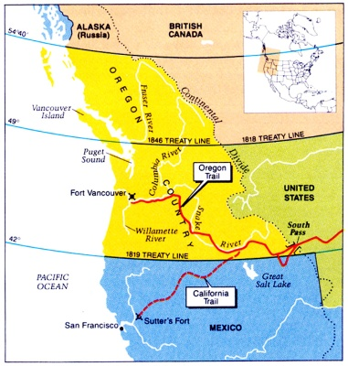

**Oregon Questions**

1. What did Great Britain and the United States decide to do with the Oregon Territory?

2. What happened to Spain and Russia?

3. How did Americans begin to hear about Oregon?

4. What happened in 1837 that made Oregon more appealing to Americans? Why?

5. What was meant by Polk’s campaign slogan “Fifty-four forty, or fight”?

6. What was eventually decided between Britain and the U.S. about the Oregon Territory?



**Oregon Questions**

1. What did Great Britain and the United States decide to do with the Oregon Territory?

2. What happened to Spain and Russia?

3. How did Americans begin to hear about Oregon?

4. What happened in 1837 that made Oregon more appealing to Americans? Why?

5. What was meant by Polk’s campaign slogan “Fifty-four forty, or fight”?

6. What was eventually decided between Britain and the U.S. about the Oregon Territory?