**FRENCH & INDIAN WAR**

1. What two European powers fought in the French & Indian War?

2. Explain two reasons that fighting broke out between the two nations?

3. Explain what this war has to do with your reading this question in English?

4. Use these images to explain why this war is so important;

MCj03970420000[1]MCj04043190000[1]MCj04238360000[1]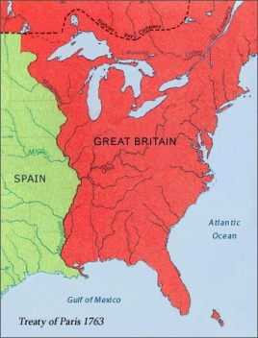MCj01965700000[1]

**FRENCH & INDIAN WAR**

1. What two European powers fought in the French & Indian War?

2. Explain two reasons that fighting broke out between the two nations?

3. Explain what this war has to do with your reading this question in English?

MCj01965700000[1]4. Use these images to explain why this war is so important;

MCj04238360000[1]MCj04043190000[1]MCj03970420000[1]