Uncle Tom’s Cabin | Kansas-Nebraska Act | Bleeding Kansas
1851 | 1854 | 1854-1856
Big ?: Did a novel start the Civil War?  Summary:  - Written by Harriet Beecher Stowe  - Was a best-selling novel, selling over 500,000 copies  - Depicted realities of slave life  - So impactful that Abraham Lincoln told Stowe “So this is the lady who made this big war!” when he met her.  Result:  - UTC was very controversial. It fueled the Abolitionist cause by opening people’s eyes to what slavery really meant, but angered people who supported and defended slavery.  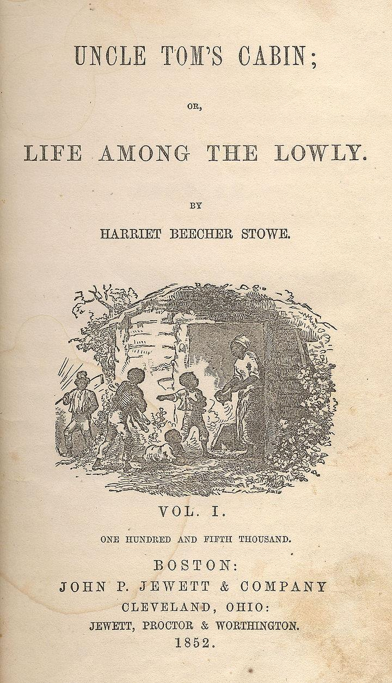 | Big ?: Should the states decide from themselves slave or free?  Summary:  The law  - Divided Nebraska Territory into two territories, Kansas and Nebraska  - Allowed citizens of the territories to decide for or against slavery. (Popular Sovereignty)  - Ended the 36-30 dividing line between slave and free from the Missouri Compromise  Result:  - Anti-slavery and pro-slavery forces go head to head in the battle over the slave or free status of Kansas.  - Many Northerners oppose the law and are outraged, leading to creation of the Republican party.  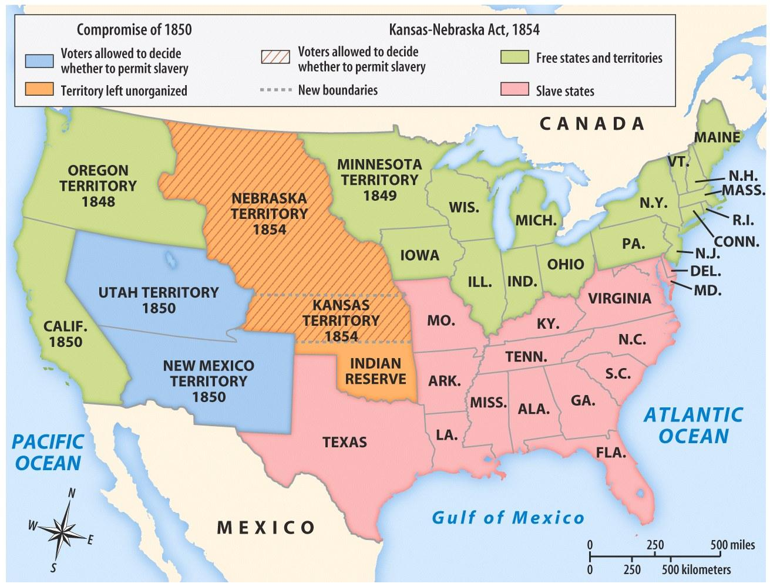 | Big ?: What happens when pro and anti-slavery forces meet>  Summary:  - As a result of the Kansas-Nebraska Act, people flock to Kansas so they can vote it slave or free. Pro-Slavery forces are called Border Ruffians, Anti-Slavery forces are Free-Soilers  - After the vote in 1855, both sides claim victory and set up their own state government.  - In 1856, Border Ruffians attack the Free Soiler’s government in Lawrence, killing one man and destroying the governor’s home.  - Four days later, abolitionist John Brown retaliates along Pottawatomie Creek, killing five innocent pro-slavery men.  - In Congress, Senator Sumner gives a speech against slavery and Senator Butler . Two days later, Butler’s nephew, southern Senator Brooks attacks Sumner with his cane and beats him unconscious, and then leaves with a broken cane.  Result:  - Brooks is considered a hero in the South, and receives new canes in the mail. The North is outraged over the attack.  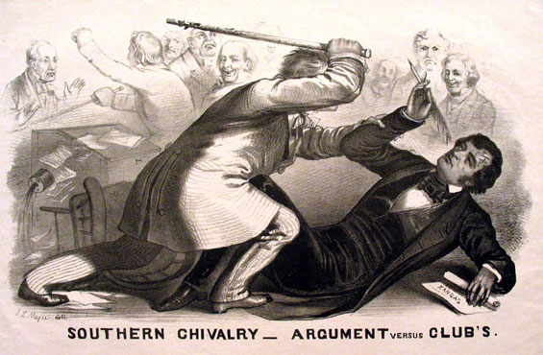
Missouri Compromise | Compromise of 1850 | Fugitive Slave Law
1820 | 1850 | 1850
Big ?: How do we divide the Louisiana Purchase between slave and free?  Summary:  - Congress had used the Northwest Ordinance to create new states and keep balance between free and slave in the NW Territory.  - Missouri, part of the Louisiana Purchase, wants to be a slave state. This could open up all of the Louisiana Territory to slavery. (South happy, North unhappy!)  - Congress is deadlocked until Henry Clay comes up with a compromise.  - Missouri joins as a slave state.  - Maine joins as free state.  - Draw an imaginary line at 36-30 latitude. No slavery above that line.  Result:  - Not everyone is happy, but they have stopped the nation from dividing. Pushes the problem of slavery into the future.  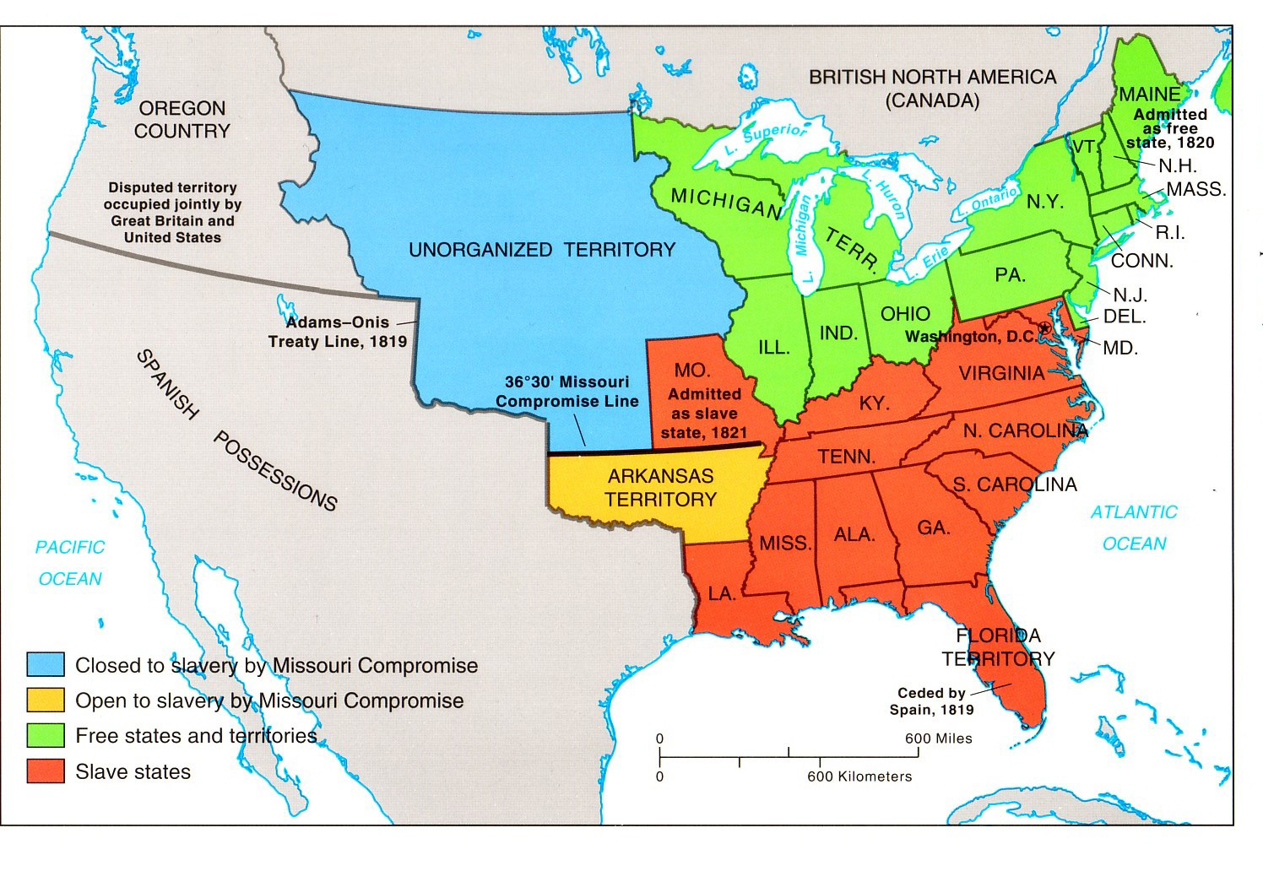 | Big ?: How do you keep both the North and South happy?  Summary:  - Missouri Compromise falls apart, because it gave more land to free states than slave states, and cut California in half.  - California wants to enter a free state.  - Henry Clay comes up with a compromise again.  - South -New, stronger fugitive slave law  - South - Citizens of each new territory (Utah & New Mexico) would vote to decide slave or free.  - North - California as a free state.  - North - Slave trade is abolished in Washington, D.C.  - Neutral - Texas gives up some of it’s territory in exchange for debt forgiveness  Result:  - The nation is once again patched together, but the divide between Slave and Free grows bigger.  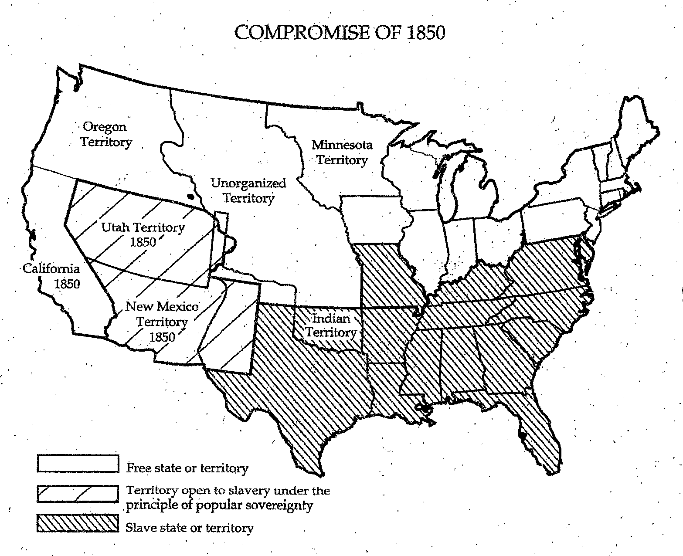 | Big ?: Who should help capture runaway slaves?  Summary:  - Passed as part of the Compromise of 1850  Law stated that:  - Accused fugitives could be arrested without a warrant  - Accused fugitive slaves had no right to trial by jury  - Federal officials were paid $5 for releasing fugitives, $10 for turning them over to owners. This made it more profitable to rule that they were slaves.  - Required people of the North to help capture and return slaves.  - People who helped fugitives slaves faced jail time and high fines.  Result:  - Northerners are angered because they can no longer ignore slavery, and are forced to help uphold it by capturing runaway slaves.  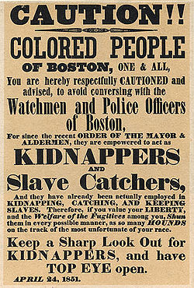

Dred Scott Decision | Lincoln-Douglas Debates | John Brown & Harper’s Ferry
1857 | 1858 | 1859
Big ?: Is a slave a citizen?  Summary:  - Dred Scott was a slave. His owner took him to Wisconsin, where slavery was banned by the Missouri Compromise. When he returned to Missouri, he sued for his freedom in court.  - Court was made up of five justices from the South, four from the North.  The court ruled:  - No African-American, slave or free, was or ever could be a citizen, so Scott had no right to sue for freedom in a federal court.  - The Missouri Compromise was ruled unconstitutional. Because slaves were property, and the Fifth Amendment said property could not be taken without due process, banning slavery in a territory was the same as taking away slave owners property from them.  Result:  - Slavery is now allowed in all territories.  - Federal gov’t has ruled that slaves are property, not people.  - Many northerners are enraged, southerners are thrilled that slavery can’t be limited in new territories.  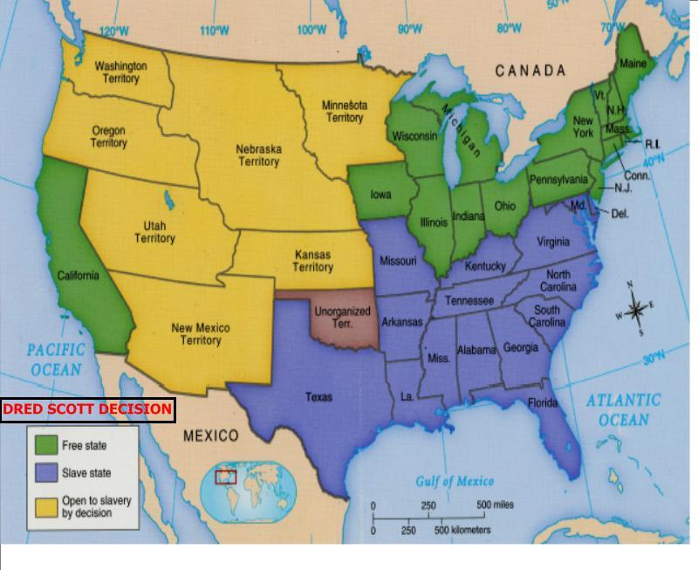 | Big ?: Who will be the next Senator from Illinois?  Summary:  - Series of seven debates between Abraham Lincoln (Republican) and Stephen Douglas (Democrat) for the Illinois seat in the U.S. Senate  - Main issue discussed was slavery and its expansion.  - Douglas is re-elected and serves as the Illinois Senator  - Widespread media coverage raises Lincoln’s profile nationally  Result:  - Lincoln becomes known throughout the country and becomes the Republican candidate for president  - Lincoln beats Douglas in the Election of 1860 and becomes president  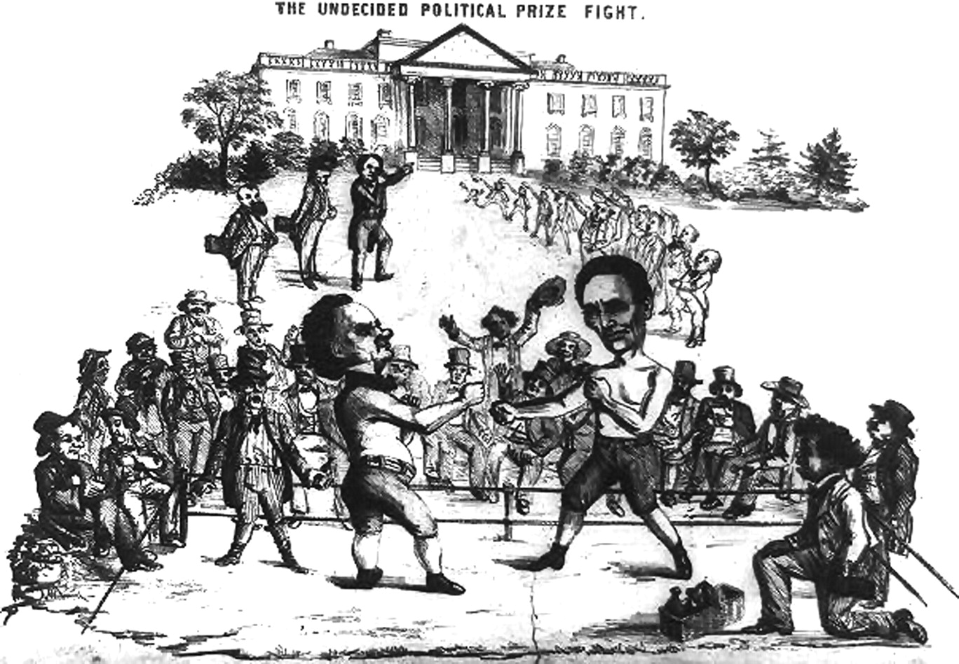 | Big ?: John Brown: Martyr or Terrorist?  Summary:  - Instead of waiting for Congress to stop slavery, John Brown takes things into his own hands  - Plots to seize the Federal arsenal at Harper’s Ferry, and use the weapons to arm slaves in a rebellion that would end slavery for good.  - All of Brown’s men are killed or captured during the raid. Brown is convicted of treason and hung.  - “I, John Brown, am now quite certain that the crimes of this guilty land will never be purged away but with blood.”  Result:  - Southerners fear another rebellion and call Brown a terrorist. Northerners view him as a hero. Nation is completely divided.  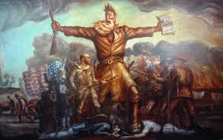
Civil War: a war fought between the people of a single country

Popular Sovereignty: the idea that the authority of the government comes from the people, the people have the power

Arsenal: a collection or storage of weapons and ammunition, usually for the military purposes

Martyr: a person who is put to death or endures great suffering on behalf of any belief, principle, or cause

Terrorist: a person who uses violence and threats to intimidate or coerce, especially for political purposes or to resist a government. Often controversial, since one person's terrorist may be another's "freedom fighter"

