Mental Health Reform Then & Now
Step 1: Turn to the next page in your spiral and turn it landscape. Label the top of the page ‘Mental Health Reform Then & Now’. Using a compass, if desired, draw as large a circle as possible below the title. Divide it into 5 even sections and label them as they are in the example below.
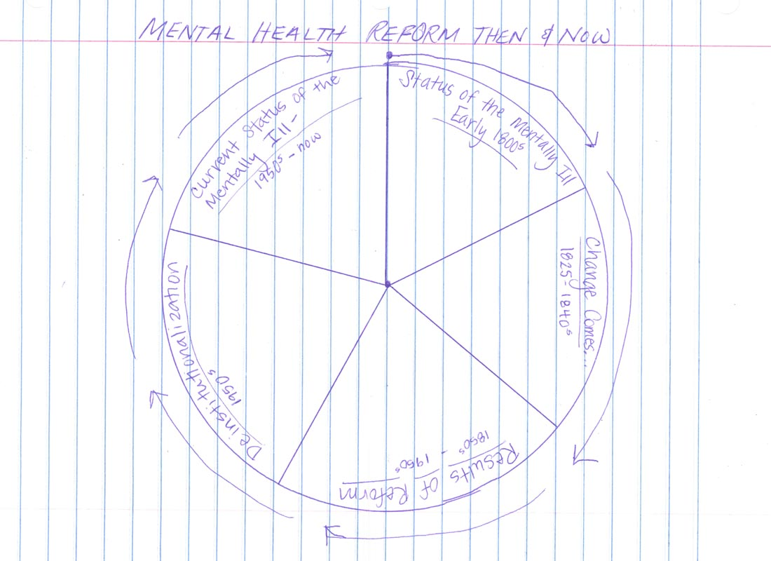
Step 2: Using the Dorothea Dix biography, fill in the first two sections of the circle and part of the third. You simply need to read the bio and sum up the main idea. Make sure you take note of where the majority of those who were mentally ill where housed at any given point. You do not need to use complete sentences as space is limited.
Step 3: Watch “History of Mental Illness” clip, stopping at 2:12, and complete section 3.
Step 4: Using the Deinstitutionalization reading, add the term deinstitutionalization to your glossary. Summarize what deinstitutionalization was and why it came about from the article into Section 4. Use bullet points.
Step 4: As a class, we will watch & discuss a clip of a documentary by PBS: Frontline entitled “The New Asylums” to complete the fifth section of our circle.

