MISSOURI COMPROMISE STATION Step #1
Use Pgs. 274-276 in the History Alive text as a resource.
Let’s do some math! In 1819, there were 22 states; 11 states had slavery, 11 were considered free states. Below, calculate the make-up of the Senate in 1819.
# ___ OF SLAVE STATES X __ SENATORS PER STATE = ____ # OF SENATORS FROM SLAVE STATES
# ___ OF FREE STATES X __ SENATORS PER STATE = ____ # OF SENATORS FROM FREE STATES
TOTAL # OF SENATORS IN 1819 = ________
When Missouri petitioned to join the Union as a slave state in 1819, it set off a major debate. Summarize the main issues;
Representation in the Senate-
Tallmadge Amendment-
Spread of slavery-
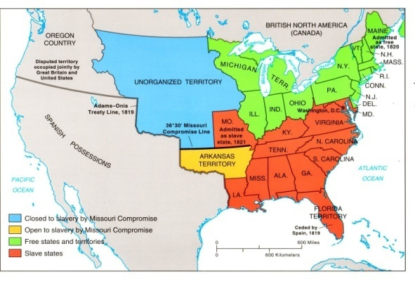 | Missouri Compromise of 1820 consisted of 3 parts;  1. __________ would enter as a slave state.  2.___________ would enter as a free state.  3. Any states that joined after this point would use the ________ to decide whether they’d be free or slave.
What can you infer will continue to be an issue as the U.S. continues to gain territory and spread westward?

MISSOURI COMPROMISE STATION Step #1
Use Pgs. 274-276 in the History Alive text as a resource.
Let’s do some math! In 1819, there were 22 states; 11 states had slavery, 11 were considered free states. Below, calculate the make-up of the Senate in 1819.
# ___ OF SLAVE STATES X __ SENATORS PER STATE = ____ # OF SENATORS FROM SLAVE STATES
# ___ OF FREE STATES X __ SENATORS PER STATE = ____ # OF SENATORS FROM FREE STATES
TOTAL # OF SENATORS IN 1819 = ________
When Missouri petitioned to join the Union as a slave state in 1819, it set off a major debate. Summarize the main issues;
Representation in the Senate-
Tallmadge Amendment-
Spread of slavery-
Missouri Compromise of 1820 consisted of 3 parts;
1. __________ would enter as a slave state.
2.___________ would enter as a free state.
3. Any states that joined after this point would use the ________ to decide whether they’d be free or slave.

What can you infer will continue to be an issue as the U.S. continues to gain territory and spread westward?

